Supporting information for:

Reversible intramolecular photocycloaddition of a bis(9-anthrylbutadienyl)paracyclophane – an inverse photochromic system. (Photoactive cyclophanes 5)

Henning Hopf,*¹ Christian Beck,¹ Jean-Pierre Desvergne,² Henri Bouas-Laurent,*² Peter G. Jones³, and Ludger Ernst⁴.

Address: ¹Institut für Organische Chemie, Technische Universität Braunschweig, Postfach 3329, D-38023 Braunschweig, Germany, ²ISM, CNRS UMR 5255, Université Bordeaux 1, F- 33405 Talence Cedex, France, ³Institut für Anorganische Chemie, Technische Universität Braunschweig, Postfach 3329, D- 38023 Braunschweig, Germany and ⁴NMR-Laboratorium der Chemischen Institute der Technischen Universität Braunschweig, Hagenring 30, D-38106 Braunschweig, Germany

Email: H. Hopf* - h.hopf@tu-bs.de; Jean-Pierre Desvergne - jp.desvergne@ism.u-bordeaux1.fr; H. Bouas-Laurent* - h.bouaslaurent@cegetel.net; Peter. G. Jones - p.jones@tu-bs.de; L. Ernst - l.ernst@tu-bs.de

* Corresponding author

Table of contents:

S2: Thermal dissociation of photoproduct 4
S3: HPLC diagram of the photochemical preparation of 4
S4: ¹H-¹H-COSY spectrum of photoproduct 4
S5: other crystal data for 2

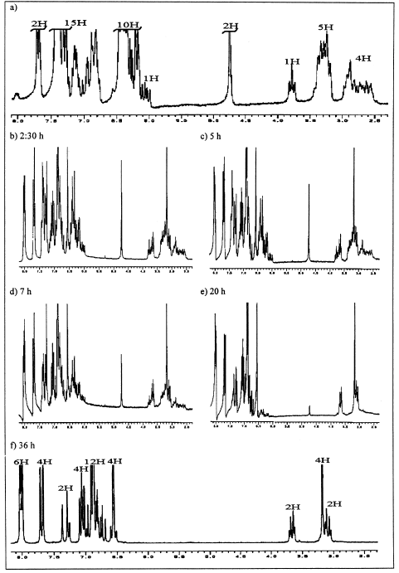

Thermal dissociation of photoproduct 4 in CDCl₃ at 55 °C. The kinetics was followed by the intensity decrease of the δ = 4.73 ppm signal, which was completed after 36 h without apparent degradation of the material.

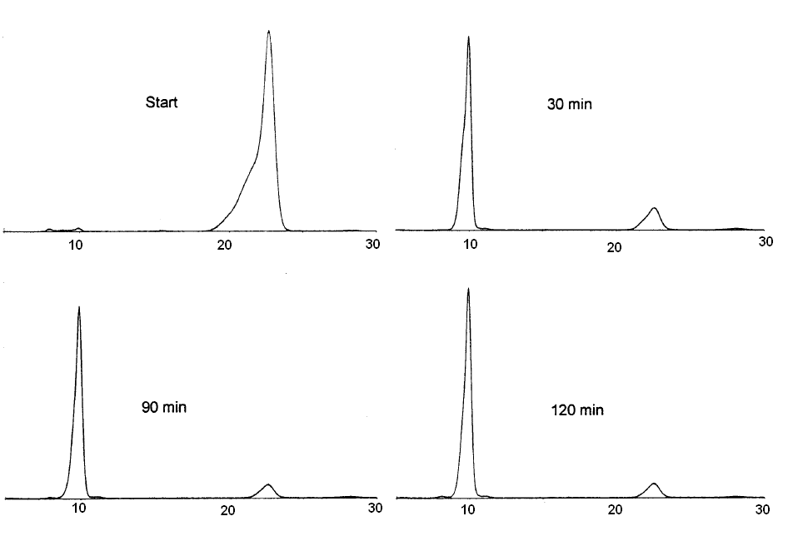
HPLC diagram of the photochemical transformation of 2 (right signal) into 4 (left signal), as a function of irradiation time, under preparative conditions (see experimental). UV detection: 290 nm

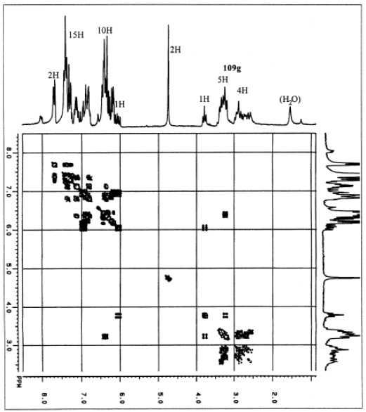

¹H-¹H-COSY spectrum of photoproduct 4

Bond precision: C-C = 0.0048 A Wavelength=0.71073
Cell: a=17.716(3) b=10.236(2) c=21.811(3)
alpha=90 beta=110.523(8) gamma=90
Temperature: 173 K
Calculated Reported
Volume 3704.2(11) 3704.1(11)
Space group P 21/c P 21/c
Hall group -P 2ybc ?
Moiety formula 2(C52 H40), C H2 Cl2 ?
Sum formula C105 H82 Cl2 C52.50 H41 CL
Mr 1414.61 707.30
Dx,g cm-3 1.268 1.268
Z 2 4
Mu (mm-1) 0.141 0.141
F000 1492.0 1492.0
F000’ 1493.11
h,k,lmax 21,12,25 21,12,24
Nref 6522 6369
Tmin,Tmax 0.967,0.986
Tmin’ 0.881
Correction method= Not given
Data completeness= 0.977 Theta(max)= 25.000
R(reflections)= 0.0522( 2592) wR2(reflections)= 0.1244( 6369)
S = 1.043 Npar= 491

