Supporting Information (Part 1)

Efficient 1,4-addition of α-substituted fluoro(phenylsulfonyl)methane derivatives to α,β-unsaturated compounds

G. K. Surya Prakash,* Xiaoming Zhao, Sujith Chacko, Fang Wang, Habiba Vaghoo and George A. Olah*
Loker Hydrocarbon Research Institute and Department of Chemistry, University of Southern California, Los Angeles, California 90089-1661
gprakash@usc.edu, olah@usc.edu

Supporting Information S2-S13
Spectra S14-S34
Experimental Section
Unless otherwise mentioned, all other reagents were purchased from commercial sources. Diethyl ether and THF were all distilled under nitrogen over sodium/benzophenone prior to use. Toluene was distilled over sodium. Column chromatography was carried out using silica gel (60-200 mesh).
¹H, ¹³C and ¹⁹F NMR spectra were recorded on Varian Mercury 400 NMR spectrometers. ¹H NMR chemical shifts were determined relative to internal (CH₃)₄Si (TMS) at δ 0.0 ppm or to the signal of a residual protonated solvent: CDCl₃ δ 7.26 ppm. ¹³C NMR chemical shifts were determined relative to internal TMS at δ 0.0 ppm or to the ¹³C signal of solvent: CDCl₃ δ 77.16 ppm. ¹⁹F NMR chemical shifts were determined relative to internal CFCl₃ at δ 0.0 ppm.
A general procedure for the oxidation of sulfides
Aqueous hydrogen peroxide (13.5 mL, 160 mmol, 30% wt) was added into a solution of the sulfide (40 mmol) in CH₃CO₂H (60 mL) at 0 °C and the reaction mixture was stirred about 2 h. The reaction mixture was allowed to warm to room temperature and stirred overnight. The mixture was poured into ice water (200 mL) and extracted with dichloromethane (200 mL). The organic phase was washed with ice water (200 mL × 3), dried over MgSO₄, and evaporated. The residue was purified by column chromatography to afford the title product (2a–2e). The characterization data of (2a–2e) [1-6], 3a [7], 3c [8] and 3d [9] are consistent with those reported earlier.
(Nitromethylsulfonyl)benzene (2a):
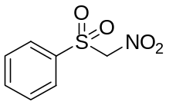
White solid, 90% yield. ¹H NMR (CDCl₃): δ 5.60 (s, 2H), 7.64–7.68 (m, 2H), 7.78–7.82 (m, 1H), 7.96–7.99 (m, 2H).
2-(Phenylsulfonyl)acetonitrile (2b):
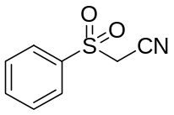
Colorless oil, 76% yield. ¹H NMR (CDCl₃): δ 4.07 (s, 2H), 7.65–7.70 (m, 2H), 7.77–7.82 (m, 1H), 8.04–8.06 (m, 2H).
Ethyl 2-(phenylsulfonyl)acetate (2c):
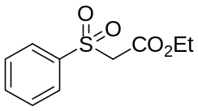
Colorless oil, in 83% yield. ¹H NMR (CDCl₃): δ 1.29 (t, J = 7.2 Hz, 3H), 4.26–4.42 (m, 2H), 7.59–7.64 (m, 2H), 7.73–7.78 (m, 1H), 7.93–7.95 (m, 2H).
1-(Phenylsulfonyl)propan-2-one (2d):
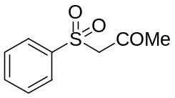
Colorless oil, in 70% yield. ¹H NMR (CDCl₃): δ 2.42 (s, 3H), 4.16 (s, 2H), 7.57–7.61 (m, 2H), 7.68–7.72 (m, 1H), 7.88–7.91 (m, 2H).
(Allylsulfonyl)benzene (2e):
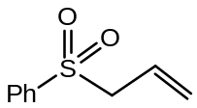
Colorless oil, in 91% yield. ¹H NMR (CDCl₃): δ 3.80–3.82 (m, 2H), 5.12–5.13 (m, 1H), 5.16–5.17 (m, 1H), 5.74–5.84 (m, 1H), 7.53–7.58 (m, 2H), 7.63–7.86 (m, 1H), 7.87–7.89 (m, 2H).
Improved procedure for the monofluorination with Selectfluor: To a slurry of NaH (6.75 mmol) in THF (15 mL) was added a solution of 1-substituted (phenylsulfonyl)methane (6.75 mmol) in THF (10 mL) at 0 °C under argon. After stirring for 2 h, a solution of Selectfluor (6.75 mmol) in anhydrous DMF (15 mL) was added dropwise to the above-mentioned mixture at 0 °C and the reaction mixture was stirred overnight, and monitored by TLC. After completion of the reaction, CH₂Cl₂ (20 mL) was added and the mixture was washed with water, brine, then the organic phase was dried with MgSO₄ and filtered. The filtrate was evaporated, and the residue was purified by column chromatography to give the title product in good yield.
[Fluoro(nitro)methylsulfonyl]benzene (3a):
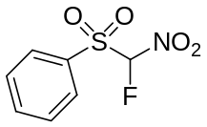
White solid isolated in 62% yield. ¹H NMR (CDCl₃): δ 6.44 (d, J = 48.4 Hz, 1H), 7.66−7.70 (m, 2H), 7.83−7.87 (m, 1H), 7.94−7.96 (m, 2H). ¹³C NMR (CDCl₃): δ 111.81 (d, J = 283.0 Hz), 130.06, 130.72, 131.43, 136.84. ¹⁹F NMR (CDCl₃): δ −142.16 (d, J = 48.4 Hz, 1F).
2-Fluoro-2-(phenylsulfonyl)acetonitrile (3b):
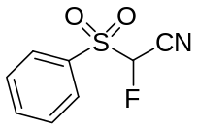
Colorless oil isolated in 45% yield. ¹H NMR (CDCl₃): δ 5.69 (d, J = 46.8 Hz, 1H), 7.68–7.73 (m, 2H), 7.84–7.88 (m, 1H), 8.04–8.07 (m, 2H). ¹³C NMR (CDCl₃): δ 88.11 (d, J = 232.3 Hz), 109.87 (d, J = 29.5 Hz), 130.00, 130.69, 132.25, 136.59. ¹⁹F NMR (CDCl₃): δ −179.23 (d, J = 47.8 Hz, 1F). HRMS Calcd for C₈H₆FNO₂S: 199.0103; Found: 199.0107.
Ethyl 2-fluoro-2-(phenylsulfonyl)acetate (3c):
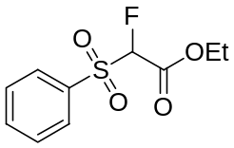
Colorless oil isolated in 56% yield. ¹H NMR (CDCl₃): δ 1.29 (t, J = 7.2 Hz, 3H), 4.29 (q, 2H), 5.57 (d, J = 48.0 Hz, 1H), 7.59–7.64 (m, 2H), 7.73–7.78 (m, 1H), 7.93–7.96 (m, 2H). ¹³C NMR (CDCl₃): δ 14.03, 63.64, 97.39 (d, J = 232.5 Hz), 129.54, 129.93, 134.65, 135.46, 161.11 (d, J = 22.9 Hz). ¹⁹F NMR (CDCl₃): δ −180.91 (d, J = 48.0 Hz, 1F).
1-Fluoro-1-(phenylsulfonyl)propan-2-one (3d):
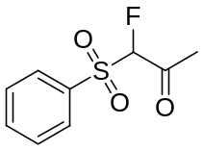
White solid isolated in 61% yield. ¹H NMR (CDCl₃): δ 2.37 (d, J = 3.6 Hz, 3H), 5.46 (d, J = 49.2 Hz, 1H), 7.61–7.65 (m, 2H), 7.75–7.77 (m, 1H), 7.92–7.95 (m, 2H). ¹³C NMR (CDCl₃): δ 27.65, 101.51 (d, J = 874.8 Hz), 129.68, 129.74, 134.95, 135.51, 195.71 (d, J = 81.7 Hz). ¹⁹F NMR (CDCl₃): δ −113.56 (tq, J = 49.2 Hz, 3.6 Hz, 1F).

General procedure:
To a solution of fluorine-substituted active methylene derivative (0.2 mmol, 1 equivalent) and methyl vinyl ketone (0.6 mmol, 3 equivalents) in THF (0.5 mL) was added trimethylphosphine (0.04 mmol, 1.0 M in THF) dropwise by syringe at room temperature under argon, and the reaction was monitored by TLC. After completion of the reaction, the solvents were removed under vacuum. The crude products were purified by column chromatography (hexane/ ethyl acetate = 3/1) to afford the products in good to excellent yield.
5-Fluoro-5-nitro-5-(phenylsulfonyl)pentan-2-one (5a):
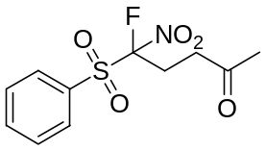
White solid isolated in 93% yield. ¹H NMR (CDCl₃): δ 2.18 (s, 3H), 2.50–2.56 (m, 1H), 2.70–2.78 (m, 1H), 2.88–2.92 (m, 1H), 2.98–3.09 (m, 1H), 7.62–7.66 (m, 2H), 7.79–7.83 (m, 1H), 7.91–7.94 (m, 2H). ¹³C NMR (CDCl₃): δ 25.56 (d, J = 17.9 Hz), 27.19, 30.01, 35.53 (d, J = 2.2 Hz), 123.63 (d, J=282.4), 125.04, 129.91, 131.09, 131.33, 136.55, 203.79. ¹⁹F NMR (CDCl₃): δ −125.90, −125.96 (dd, J₁ = 28.6 Hz, 10.5 Hz, 1F). HRMS: (FAB) calcd for C₁₁H₁₃FNO₅S 290.0499 (M+1) found: m/z 290.0500.
2-Fluoro-5-oxo-2-(phenylsulfonyl)hexanenitrile (5b):
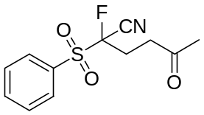
White solid isolated in 90% yield. ¹H NMR (CDCl₃): δ 2.23 (s, 3H), 2.66–2.75 (m, 1H), 2.85–2.92 (m, 1H), 7.65–7.69 (m, 2H), 7.81–7.85 (m, 1H), 8.02–8.04 (m, 2H). ¹³C NMR (CDCl₃): δ 25.84 (d, J = 21.4 Hz), 30.00, 36.82 (d, J = 2.4 Hz), 99.20 (d, J = 228.8 Hz), 112.24 (d, J = 33.1 Hz), 129.75, 131.14, 132.04, 136.32, 204.03. ¹⁹F NMR (CDCl₃): δ −148.50 (dd, J= 27.1 Hz, 16.9 Hz, 1F). HRMS: (FAB) calcd for C₁₂H₁₃FNO₃S 270.0600 (M+1) found: m/z 270.0612.
Ethyl 2-fluoro-5-oxo-2-(phenylsulfonyl)hexanoate (5c):
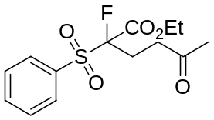
White solid isolated in 75% yield. ¹H NMR (CDCl₃): δ 1.20 (t, J = 7.2 Hz, 3H), 2.14 (s, 3H), 2.49–2.56 (m, 2H), 2.67–2.78 (m, 2H), 4.15–4.23 (m, 2H), 7.56–7.60 (m, 2H), 7.70–7.74 (m, 1H), 7.89–7.92 (m, 2H). ¹³C NMR (CDCl₃): δ 13.93, 25.28 (d, J = 19.9 Hz), 29.92, 36.48 (d, J = 3.2 Hz), 63.58, 106.26 (d, J = 233.3 Hz), 129.30, 130.45, 134.13, 135.24, 163.63 (d, J = 24.8 Hz), 205.27. ¹⁹F NMR (CDCl₃): δ −158.34 (m, 1F). HRMS: (FAB) calcd for C₁₄H₁₈FNO₅S 317.0859 (M+1) found: m/z 317.0861.
5-Fluoro-5,5-bis(phenylsulfonyl)pentan-2-one (5d):
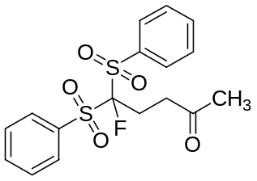
White solid isolated in 91% yield. ¹H NMR (CDCl₃): δ 2.17 (s, 3H), 2.56–2.64 (m, 2H), 3.05–3.09 (m, 2H), 7.55–7.59 (m, 4H), 7.72–7.76 (m, 2H), 7.91–7.93 (m, 4H). ¹³C NMR (CDCl₃): δ 24.81 (d, J = 18.9 Hz), 29.95, 36.51 (d, J = 6.2 Hz), 115.07 (d, J = 264.4 Hz), 129.20, 130.99, 134.89, 135.52. ¹⁹F NMR (CDCl₃): δ −140.70 (t, J = 15.4 Hz, 1F). HRMS: (FAB) calcd for C₁₇H₁₈FO₅S₂ 385.0580 (M+1) found: m/z 385.0565.
Ethyl 4-fluoro-4-nitro-4-(phenylsulfonyl)butanoate (5e):
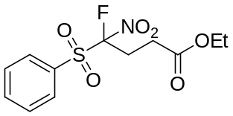
White solid isolated in 64% yield. ¹H NMR (CDCl₃): δ 1.26 (t, J = 7.2 Hz, 3H), 2.31–2.39 (m, 1H), 2.50–2.58 (m, 1H), 2.87–2.95 (m, 1H), 3.04–3.20 (m, 1H), 4.11 (q, J = 7.2 Hz, 2H), 7.58–7.62 (m, 2H), 7.76–7.80 (m, 1H), 7.88–7.90 (m, 2H). ¹³C NMR (CDCl₃): δ 14.37, 26.70 (d, J = 18.2 Hz), 27.04 (d, J = 3.8 Hz), 61.73, 123.43 (d, J = 282.8 Hz), 130.04, 131.22, 131.27, 136.73, 170.35. ¹⁹F NMR (CDCl₃): δ −126.70 (dd, J= 30.1 Hz, 9.8 Hz, 1F). HRMS: (FAB) calcd for C₁₂H₁₅FNO₆S 320.0604 (M+1) found: m/z 320.0612.
Ethyl 4-cyano-4-fluoro-4-(phenylsulfonyl)butanoate (5f)
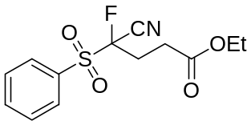
White solid isolated in 60% yield. ¹H NMR (CDCl₃): δ 1.30 (t, J = 7.2 Hz, 3H), 2.70–2.83 (m, 4H), 4.17–4.22 (m, J = 7.2 Hz, 2H), 7.66–7.70 (m, 2H), 7.81–7.86 (m, 1H), 8.03–8.06 (m, 2H). ¹³C NMR (CDCl₃): δ 14.32, 27.59 (d, J = 18.9 Hz), 28.33 (d, J = 3.0 Hz), 61.59, 99.04 (d, J = 228.8 Hz), 112.15 (d, J = 33.2 Hz), 129.86, 131.28, 132.08, 136.44, 170.49. ¹⁹F NMR (CDCl₃): δ −149.63 (m, 1F). HRMS: (FAB) calcd for C₁₃H₁₅FNO₄S 300.0706 (M+1) found: m/z 300.0719.
Diethyl 2-fluoro-2-(phenylsulfonyl)pentanedioate (5g):
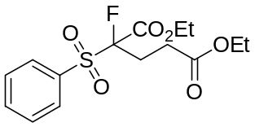
White solid isolated in 71% yield. ¹H NMR (CDCl₃): δ 1.18–1.25 (m, 6H), 2.32–2.38 (m, 1H), 2.55–2.59 (m, 2H), 2.76–2.84 (m, 1H), 4.06–4.21 (m, 4H), 7.54–7.58 (m, 2H), 7.68–7.72 (m, 1H), 7.87–7.90 (m, 2H). ¹³C NMR (CDCl₃): δ 14.15, 14.41, 26.63 (d, J = 20.2 Hz), 28.05 (d, J = 3.4 Hz), 61.31, 63.82, 106.38 (d, J = 234.5 Hz), 129.51, 130.67, 134.23, 135.47, 163.61 (d, J = 25.5 Hz), 171.40. ¹⁹F NMR (CDCl₃): δ −159.13 (dd, J= 31.2 Hz, 10.5 Hz, 1F). HRMS: (FAB) calcd for C₁₅H₂₀FNO₆S 347.0965 (M+1) found: m/z 347.0962.
Ethyl 4-fluoro-4,4-bis(phenylsulfonyl)butanoate (5h):
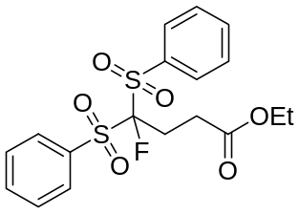
White solid isolated in 88% yield. ¹H NMR (CDCl₃): δ 1.20 (t, J = 7.2 Hz, 3H), 2.62–2.71 (m, 2H), 2.78–2.83 (m, 2H), 4.04–4.09 (m, 2H), 7.51–7.56 (m, 2H), 7.68–7.72 (m, 1H), 7.88–7.90 (m, 2H). ¹³C NMR (CDCl₃): δ 14.22, 26.01 (d, J = 19.4 Hz), 27.69 (d, J = 7.7 Hz), 61.06, 114.75 (d, J = 266.1 Hz), 129.21, 130.96, 134.85, 135.52, 171.43. ¹⁹F NMR (CDCl₃): δ −142.91 (t, J = 15.8 Hz, 1F). HRMS: (FAB) calcd for C₁₈H₂₀FO₆S₂ 415.0685 (M+1) found: m/z 415.0673.
General procedure:
To a solution of fluorine-substituted active methylene derivative (0.16 mmol, 1 equivalent) and α,β-unsaturated compound (0.16 mmol, 1 equivalent) in DMF (2 mL) was added potassium carbonate (0.36 mmol, 0.050 g) at room temperature and the reaction was monitored by ¹⁹F NMR. Aqueous work up followed by extraction with dichloromethane (3 x 15 mL) afforded the crude product. The pure product was obtained by column chromatography.
4,4-Bis(benzenesulfonyl)-4-fluoro-2-methyl-butyric acid methyl ester (6a)
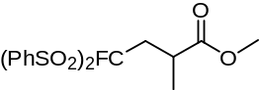
Colorless oil isolated in 70% yield. ¹H NMR (CDCl₃): δ 1.18 (d, J = 6.8 Hz, 3H), 2.44–2.58 (m, 1H), 2.50–2.58 (m, 1H), 2.92 (dd, J = 29.4 Hz, 0.5 Hz, 1H), 2.96–3.11 (m, 2H), 3.51 (s, 3H), 7.55–7.61 (m, 4H), 7.71–7.77 (m, 2H), 7.87–7.99 (m, 4H). ¹³C NMR (CDCl₃): δ 18.99, 32.84 (d, J = 17.5 Hz), 34.74 (d, J = 5.8 Hz), 51.95, 114.80 (d, J = 268.6 Hz), 128.96, 129.01, 130.93, 130.95, 134.41, 134.77, 135.28, 135.32, 175.07 ¹⁹F NMR (CDCl₃): δ −146.50 (dd, J = 22.8 Hz, 10.5 Hz, 1F) HRMS: (FAB) calcd for C₁₈H₁₉FO₆S₂ 415.0685 (M+1) found: m/z 415.0668.
4,4-Bis(benzenesulfonyl)-4-fluoro-2-methyl-butyric acid tert-butyl ester (6c)
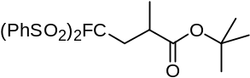
White solid isolated in 70% yield. ¹H NMR (CDCl₃): δ 1.13 (d, J = 7.1Hz, 3H), 1.34 (s, 9H), 2.43 (ddd, J =23.5 Hz, 15.8 Hz, 3.9 Hz, 1H), 2.80–2.90 (m, 1H), 2.91–3.02 (m, 1H), 7.54–7.62 (m, 4H), 7.70–7.77 (m, 2H), 7.88–8.00 (m, 4H). ¹³C NMR (CDCl₃): δ 19.03, 27.75 (d, J = 11.9 Hz), 32.81 (d, J = 17.3 Hz), 35.76 (d, J = 5.7 Hz), 80.52, 115.11 (d, J = 268.4 Hz), 128.96, 129.01, 130.96, 134.53, 134.95, 135.23, 135.26, 173.93. ¹⁹F NMR (CDCl₃): δ −146.17 (dd, J = 10.7 Hz, 23.6 Hz, 1F) HRMS: (FAB) calcd for C₂₁H₂₅FO₆S₂ 457.1155 (M+1) found: m/z 457.1147.
3-[Bis(benzenesulfonyl)-fluoro-methyl]-cyclohexanone (6d)
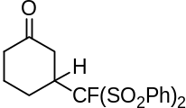
White solid isolated in 90% yield. ¹H NMR (CDCl₃): δ 1.40–1.56 (m, 1H), 2.15–2.25 (m, 1H), 2.30–2.47 (m, 3H), 2.52–2.80 (m, 3H), 3.03–3.13 (m, 1H), 7.48–7.57 (m, 4H), 7.68–7.75 (m, 2H), 7.77–7.83 (m, 2H), 7.85–7.91 (m, 2H) ¹³C NMR (CDCl₃): δ 25.10, 25.15, 41.07, 41.36 (d, J = 6.9 Hz), 42.67 (d, J = 17.2 Hz), 114.41 (d, J = 266.4 Hz), 114.45, 128.83, 129.09, 130.58, 130.59, 130.76, 130.78, 134.87, 135.20, 135.34, 135.77, 207.82. ¹⁹F NMR (CDCl₃): δ −136.36 (s, 1F) HRMS: (FAB) calcd for C₁₉H₁₉FO₅S₂ 411.0736 (M+1) found: m/z 411.0740.
6,6-Bis(benzenesulfonyl)-6-fluoro-hexan-3-one (6e)
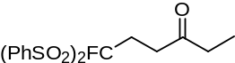
White solid isolated in 79% yield. ¹H NMR (CDCl₃): δ.1.04 (d, J = 7.4 Hz, 3H), 2.46 (q, J = 7.3 Hz, 2H), 2.58–2.68 (m, 2H), 3.00–3.08 (m, 2H), 7.55–7.62 (m, 4H), 7.70–7.77 (m, 2H), 7.90–7.95 (m, 4H) ¹³C NMR (CDCl₃): δ 24.75 (d, J = 18.4 Hz), 35.00, 35.05, 35.82, 115.03 (d, J = 264.5 Hz), 129.06, 130.83, 130.85, 134.79, 135.37, 207.99. ¹⁹F NMR (CDCl₃): δ −140.74 (t, J = 15.9 Hz, 1F) HRMS: (FAB) calcd for C₁₈H₁₉FO₅S₂ 399.0736 (M+1) found: m/z 399.0742.
3,3-Bis(benzenesulfonyl)-3-fluoro-1-(methylsulfonyl)propane (6f)
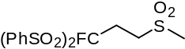
White solid isolated in 60% yield. ¹H NMR (CDCl₃): δ.2.77–2.87 (m, 2H), 2.99 (s, 3H), 3.60–3.67 (m, 2H), 7.57–7.63 (m, 4H), 7.74–7.80 (m, 2H), 7.91–7.96 (m, 4H) ¹³C NMR (CDCl₃): δ 24.01(d, J = 20.7 Hz), 40.99, 48.12 (d, J = 6.9 Hz), 113.11 (d, J = 266.1Hz), 129.29, 130.94, 134.01, 135.82 ¹⁹F NMR (CDCl₃): δ −140.35 (t, J = 14.0 Hz, 1F) HRMS: (FAB) calcd for C₁₆H₁₇FO₆S₃ 421.0249 (M+1) found: m/z 421.0262.
4,4-Bis(benzenesulfonyl)-4-fluoro-butyronitrile (6g)
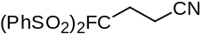
White solid. ¹H NMR (CDCl₃): δ 2.70–2.79 (m, 2H), 2.91–2.97 (m, 2H), 7.56–7.63 (m, 4H), 7.80–7.74 (m, 2H), 7.88–7.93 (m, 4H). ¹³C NMR (CDCl₃): δ 12.07 (d, J = 9.2 Hz), 26.94 (d, J = 18.4 Hz), 113.00 (d, J = 267.6 Hz), 117.561, 129.34, 130.83, 134.10, 135.82. ¹⁹F NMR (CDCl₃): δ −145.04 (t, J = 15.5 Hz, 1F) HRMS: (FAB) calcd for C₁₆H₁₄FNO₄S₂ 368.0426 (M+1) found: m/z 368.0445.
2-[2,2-Bis(benzenesulfonyl)-2-fluoroethyl]-pentanedinitrile (6h)
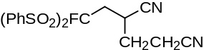
White solid. ¹H NMR (CDCl₃): δ 1.90–2.20 (m, 2H), 2.43–2.68 (m, 2H), 2.76–2.88 (m, 2H), 3.32–3.42 (m, 1H), 7.55–7.64 (m, 4H), 7.74–7.82 (m, 2H), 7.84–7.88 (m, 2H), 7.93–7.97 (m, 2H). ¹³C NMR (CDCl₃): δ 15.09, 25.95 (d, J = 5.4 Hz), 28.81, 32.13 (d, J = 17.6 Hz), 112.95 (d, J = 269.9 Hz), 117.37, 118.56, 129.32, 129.51, 130.80, 131.01, 133.35, 133.95, 135.95. ¹⁹F NMR (CDCl₃): δ −146.55 (dd, J = 19.5 Hz, 12.9 Hz, 1F) HRMS: (FAB) calcd for C₁₉H₁₇FN₂O₄S₂ 421.0692 (M+1) found: m/z 421.0688.
4,4-Bis(benzenesulfonyl)-4-fluoro-but-2-enoic acid methyl ester (6j)
cis
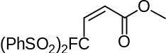
¹H NMR (CDCl₃): δ 3.75 (s, 3H), 5.97 (d, J = 15.7 Hz, 1H), 7.27 (dd, J = 23.1 Hz, 15.7 Hz, 1H), 7.55–7.61 (m, 4H), 7.72–7.78 (m, 2H), 7.91–7.96 (m, 4H). ¹³C NMR (CDCl₃): δ 52.43, 112.86 (d, J = 269.1 Hz), 129.12, 129.77 (d, J = 9.2 Hz), 130.59 (d, J = 14.6 Hz), 130.89, 134.40, 135.79. ¹⁹F NMR (CDCl₃): δ −150.93 (d, J = 23.1 Hz, 1F) HRMS: (FAB) calcd for C₁₇H₁₅FO₆S₂ 399.0372 (M+1) found: m/z 399.0379.
trans
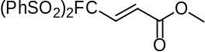
¹H NMR (CDCl₃): δ 3.42 (s, 3H), 6.18 (dd, J = 12.9 Hz, 1.3 Hz, 1H), 6.44 (dd, J = 28.5 Hz, 12.9 Hz, 1H), 7.56–7.62 (m, 4H), 7.73–7.78 (m, 2H), 7.93–7.98 (m, 4H). ¹³C NMR (CDCl₃): δ 51.96, 113.53 (d, J = 273.0 Hz), 121.26 (d, J = 13.80 Hz), 128.98, 130.78 (d, J = 3.07 Hz), 131.06, 134.48, 135.54, 164.13. ¹⁹F NMR (CDCl₃): δ −150.60 (d, J = 28.5 Hz, 1F) HRMS: (FAB) calcd for C₁₇H₁₅FO₆S₂ 399.0372 (M+1) found: m/z 399.0379.
4,4-Bis(benzenesulfonyl)-4-fluoro-but-2-enoic acid ethyl ester (6k)
cis
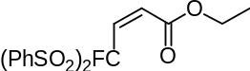
White solid. ¹H NMR (CDCl₃): δ 1.28 (t, J = 7.1 Hz, 3H), 4.19 (q, J = 7.1 Hz, 2H), 5.96 (dd, J = 15.7 Hz, 0.4 Hz, 1H), 7.25 (dd, J = 23.1 Hz, 15.7 Hz, 1H), 7.55–7.62 (m, 4H), 7.72–7.78 (m, 2H), 7.91–7.96 (m, 4H). ¹³C NMR (CDCl₃) : δ 14.00, 61.44, 112.80 (d, J = 269.1 Hz), 129.06, 130.09 (d, J = 9.1 Hz), 130.21 (d, J = 3.2 Hz), 130.79, 134.31, 135.75, 163.23. ¹⁹F NMR (CDCl₃): δ −150.90 (d, J = 23.1 Hz, 1F) HRMS: (FAB) calcd for C₁₈H₁₇FO₆S₂ 413.0529 (M+1) found: m/z 413.0543.
trans
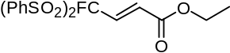
White solid. ¹H NMR (CDCl₃): δ 1.07 (dt, J = 7.1 Hz, 0.4 Hz, 3H), 3.91 (q, J = 7.1Hz, 2H), 6.17 (dd, J = 12.9 Hz, 1.3 Hz, 1H), 6.41 (dd, J = 28.7 Hz, 13.0 Hz, 1H), 7.56–7.62 (m, 4H), 7.73–7.78 (m, 2H), 7.94–7.98 (m, 4H). ¹³C NMR (CDCl₃): δ 13.85, 61.08, 113.63 (d, J = 274.0 Hz), 120.68 (d, J = 13.8 Hz), 128.97, 130.98, 130.99, 131.26 (d, J = 2.9 Hz), 134.55, 135.50, 163.69. ¹⁹F NMR (CDCl₃): δ −150.32 (d, J = 28.7 Hz, 1F) HRMS: (FAB) calcd for C₁₈H₁₇FO₆S₂ 413.0529 (M+1) found: m/z 413.0543.
4-(Benzenesulfonyl)-4-fluoro-4-nitro-but-2-enoic acid ethyl ester (6l)
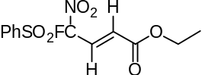
White solid. ¹H NMR (CDCl₃): δ 1.23 (t, J = 7.1 Hz), 4.16 (q , J = 7.2 Hz), 6.50 (dd, J = 12.4, 2.4 Hz, 1H), 6.79 (dd, J = 18.7, 12.3 Hz, 1H), 7.63–7.69 (m, 2H), 7.81–7.87 (m, 1H), 7.92–7.97 (m, 2H). ¹³C NMR (CDCl₃): δ 13.78, 61.94, 123.83 (d, J = 15.3 Hz), 129.68, 131.17, 131.50 (d, J = 288.3 Hz), 136.56, 163.12. ¹⁹F NMR (CDCl₃): δ −119.05 (d, J = 18.3 Hz, 1F) HRMS: (FAB) calcd for C₁₂H₁₂FNO₆S 318.0447 (M+1) found: m/z 318.0445.
References
- Wade, P. A.; Hinney, H. R.; Amin, N. V.; Vail, P. D.; Morrow, S. D.; Hardinger, S. A.; Saft, M. S. J. Org. Chem. 1981, 46, 765–770. doi:10.1021/jo00317a023
- Truce, W. E.; Klingler, T. C.; Paar, J. E.; Feuer, H.; Wu, D. K. J. Org. Chem. 1969, 34, 3104–3107. doi:10.1021/jo01262a068
- Walker, D. J. Org. Chem. 1966, 31, 835–837. doi:10.1021/jo01341a045
- Doyle, K. J.; Moody, C. J. Tetrahedron 1994, 50, 3761–3772. doi:10.1016/S0040-4020(01)90396-5
- Ohta, H.; Kato, Y.; Tsuchihashi, G. J. Org. Chem. 1987, 52, 2735–2739. doi:10.1021/jo00389a018
- Sheldrake, H. M.; Wallace, T. W. Tetrahedron Lett. 2007, 48, 4407–4411. doi:10.1016/j.tetlet.2007.04.099
- Prakash, G. K. S.; Chacko, S.; Alconcel, S.; Stewart, T.; Mathew, T.; Olah, G. A. Angew. Chem., Int. Ed. 2007, 46, 4933–4936. doi:10.1002/anie.200700834
- Takeuchi, Y.; Asahina, M.; Hori, K.; Koizumi, T. J. Chem. Soc., Perkin Trans. 1 1988, 1149–1153. doi:10.1039/P19880001149
- Takeuchi, Y.; Ogura, H.; Kanada, A.; Koizumi, T. J. Org. Chem. 1992, 57, 2196–2199. doi:10.1021/jo00033a058


