Supporting Information: ¹H NMR and ¹³C NMR spectra of selected compounds

Studies on polynuclear furoquinones. Part 1: Synthesis of tri- and tetra-cyclic furoquinones simulating BCD/ABCD ring system of furoquinone diterpenoids.

Faruk Hasan Shaik, Gandhi Kumar Kar*

Department of Chemistry, Presidency College, 86/1 College Street, Kolkata-700073, India

*Corresponding author

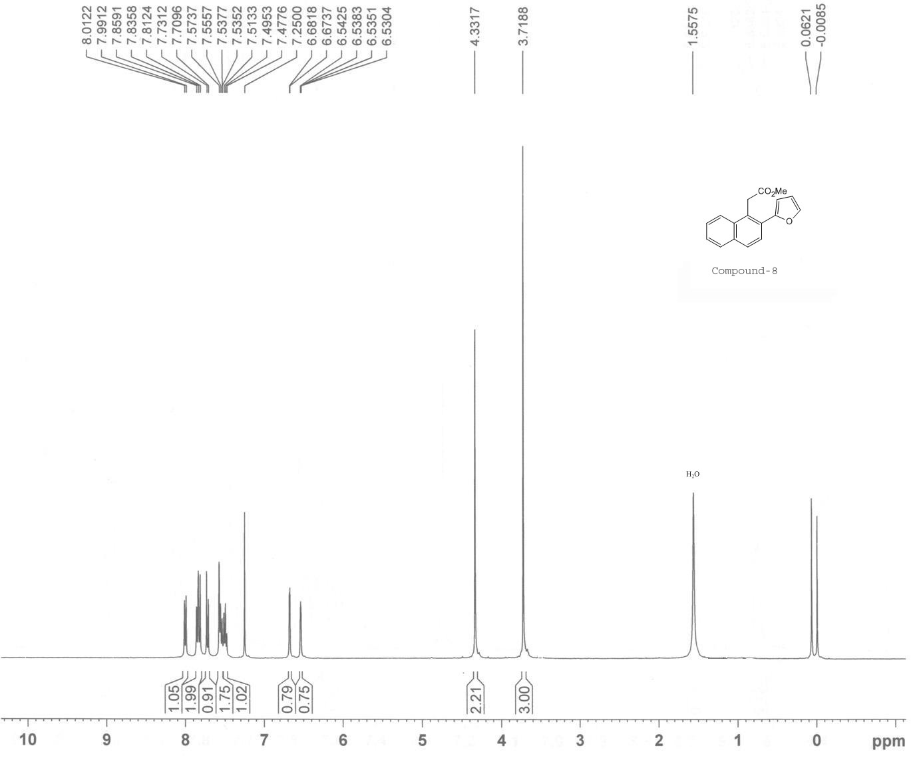

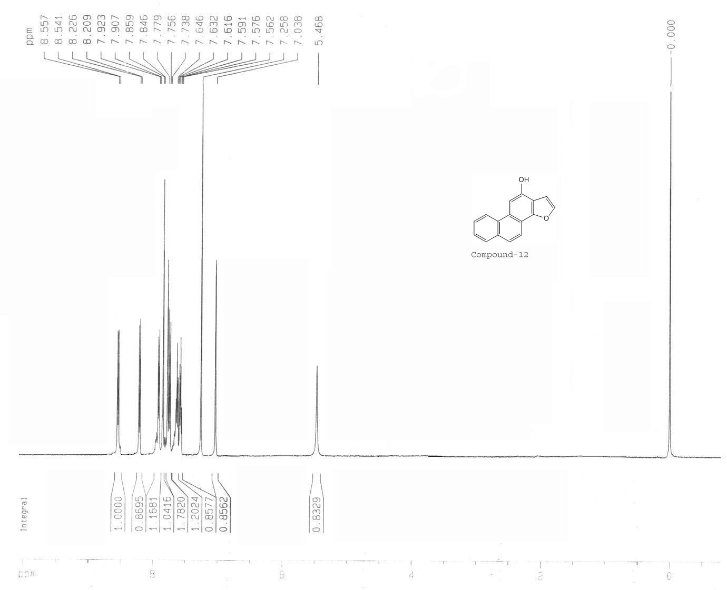

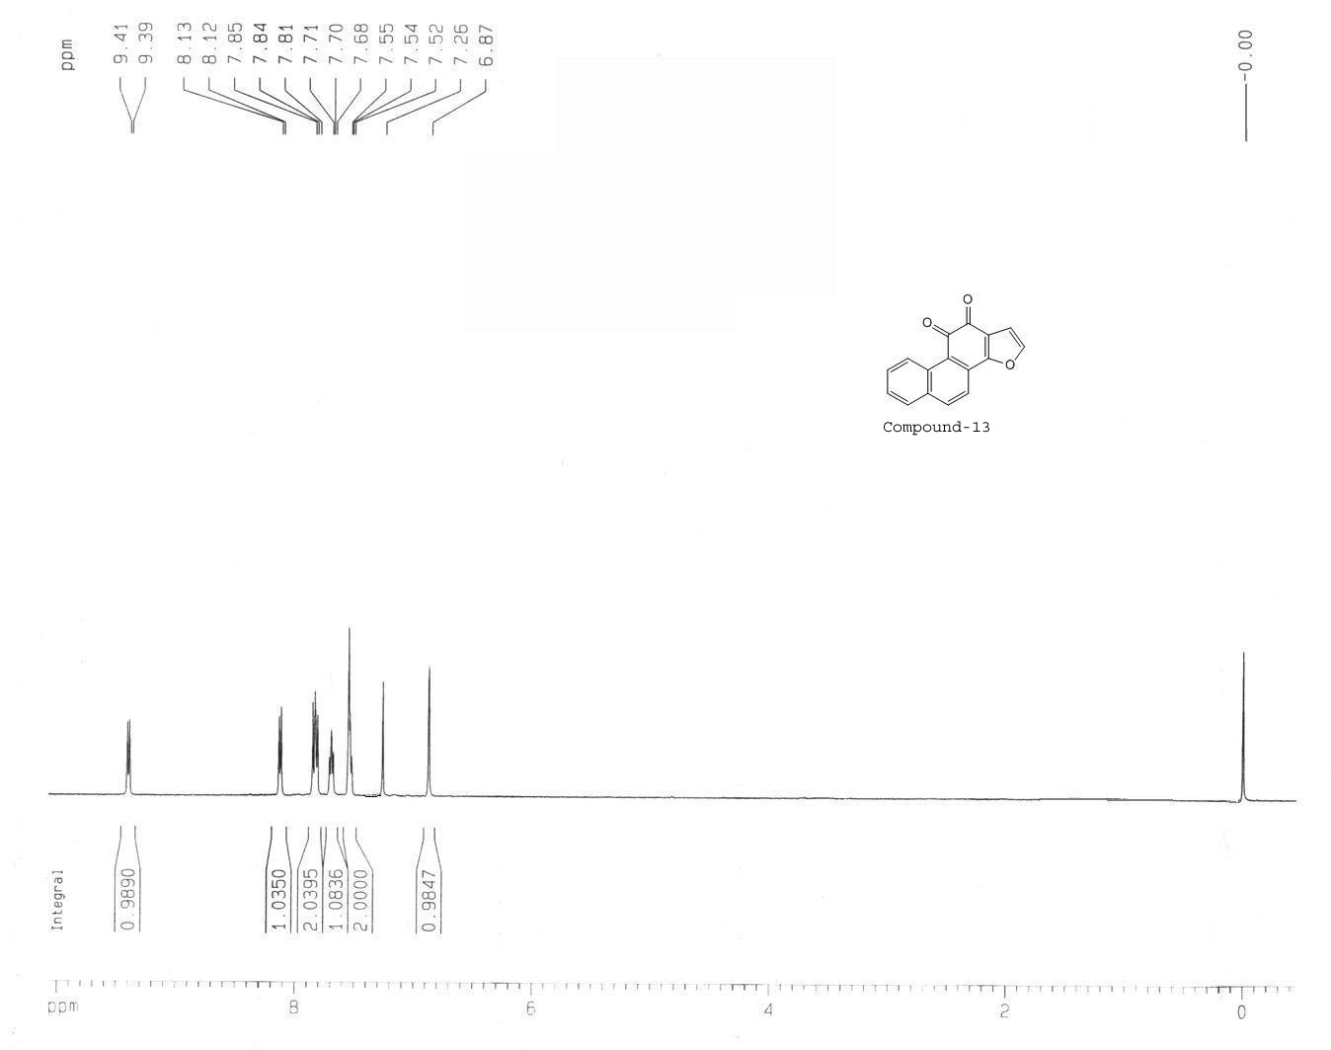

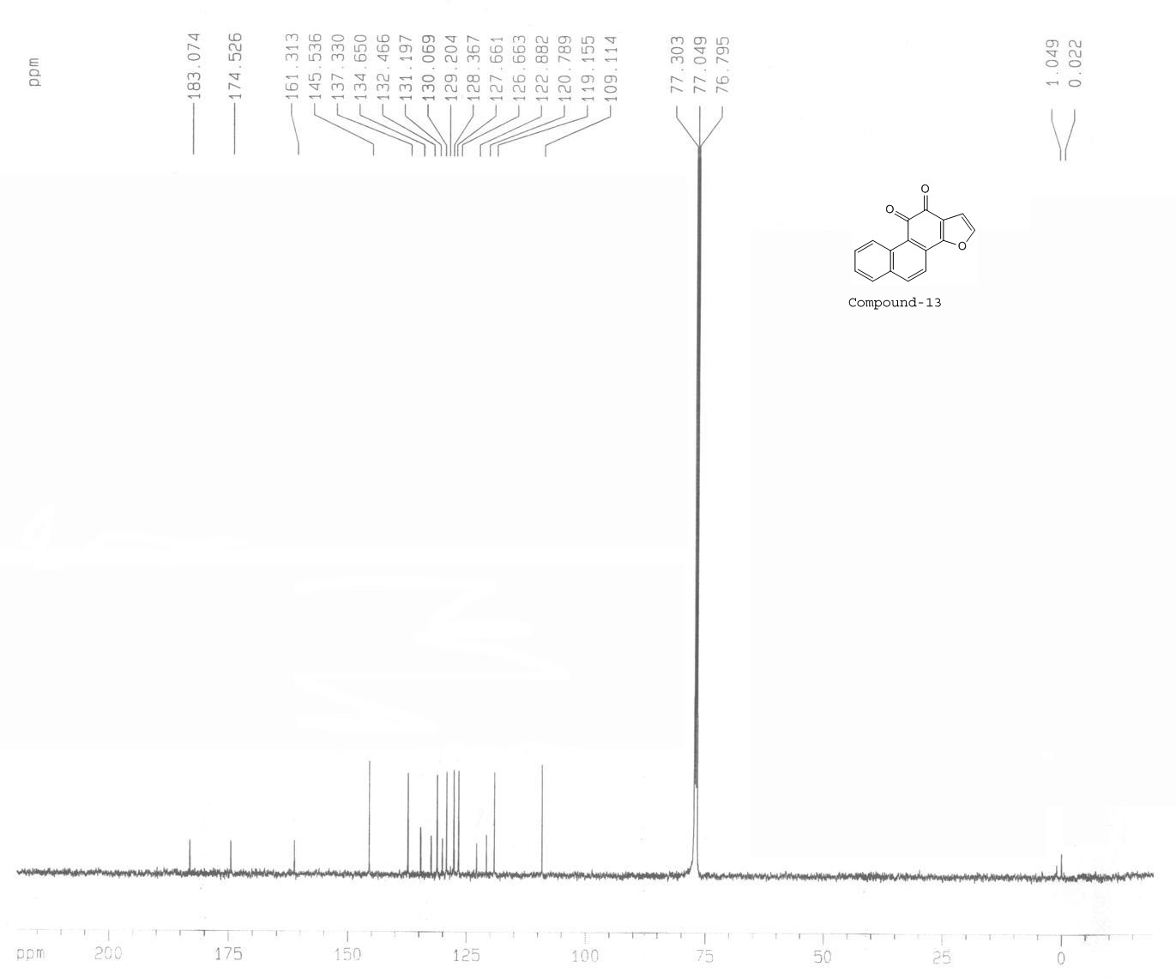

HSQC Spectra of compound-13:


