Figure 1S: Valence-prime structures of the isomers in the mono- and bis-oxidised states

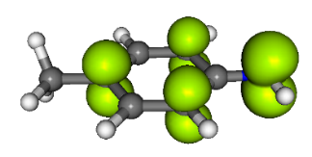  –0.02 / 0.64 | 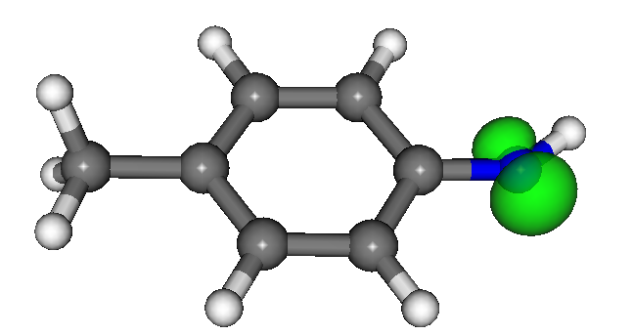  –0.00 / 0.94
p-CH₃TNH● (π-state)  –326.204527 hartree | p-CH₃TNH. (σ-state)  –326.145215 hartree
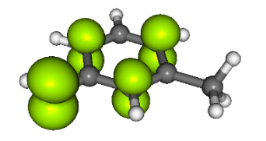  0.65 / 0.02 | 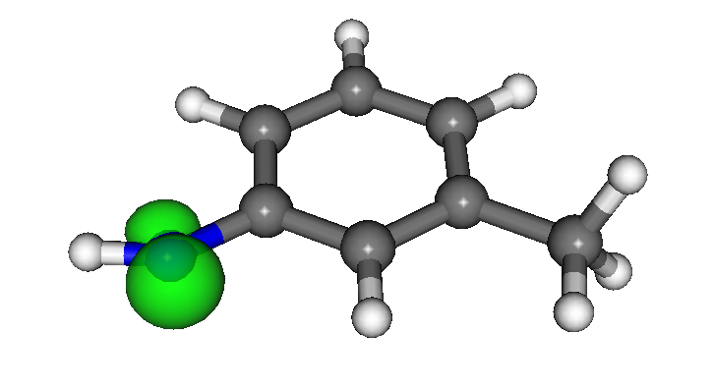  0.96 / –0.00
m-CH₃TNH● (π-state)  –326.203661 hartree | p-CH₃TNH● (σ-state)  –326.147076 hartree
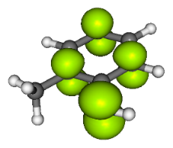  –0.01 / 0.62 | 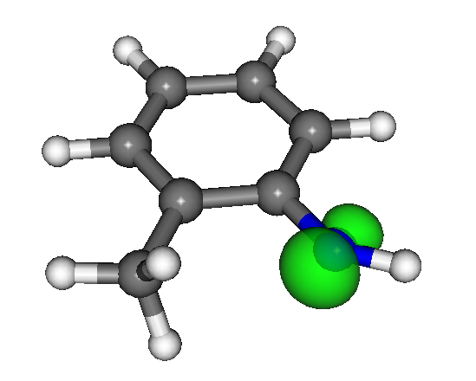  0.00 / 0.96
o-CH₃TNH● (π-state)  –326.206300 hartree | p-CH₃TNH● (σ-state)  –326.149204 hartree
Figure 2S: The gas-phase electron B3LYP energies, Mulliken spin density distribution in the toluidine isomers in their different oxidised radical states. The depicted iso-surface value is 0.30 atomic units. The spin densities for nitrogen atom / carbon atoms of substitutents are in atomic units.

Table 1S. Reaction M062x Gibb´s free energies for selected acido-basic steps calculated for the gas-phase and solvents (energies in kJ mol^{–1}).
Reaction No. | Acid-base reaction
 |  |  | gas |  |  |  | DMSO |  |  |  | water
a | ANH₃+→ ANH₂ + H⁺ |  | 850.4 |  |  |  | –53.5 |  |  |  | –31.1
b | ANH₂ → ANH⁻ + H⁺ |  | 1505.9 |  |  |  | 165.9 |  |  |  | 183.1
c | ANH₂^{+●} → ANH● + H⁺ |  | 925.5 |  |  |  | –4.5 |  |  |  | 16.3
 |  | ortho | meta | para |  | ortho | meta | para |  | ortho | meta | para
1 | CH₃TNH₃⁺ → CH₃TNH₂ + H⁺ | 857.1 | 857.6 | 862.2 |  | –52.4 | –51.7 | –47.1 |  | –29.6 | –30.9 | –26.4
2 | CH₃TNH₂ → CH₃TNH₂– + H⁺ | 1503.3 | 1509.4 | 1510.2 |  | 167.9 | 169.8 | 170.8 |  | 185.0 | 186.7 | 188.2
Δ(G₁ – G₂) |  | –646.2 | –651.8 | –648.0 |  | –220.3 | –221.5 | –217.9 |  | –214.7 | –217.2 | –215.4
3 | CH₃TNH₃⁺⁻ → CH₂TNH₃⁺⁻⁻ + H⁺ | 1128.9 | 1181.4 | 1186.4 |  | 166.5 | 188.2 | 193.2 |  | 188.4 | 208.2 | 212.4
4 | CH₃TNH₂ → CH₂TNH₂– + H⁺ | 1571.1 | 1572.2 | 1589.2 |  | 236.9 | 234.8 | 254.0 |  | 254.0 | 251.9 | 270.5
5 | CH₃TNH– → CH₂TNH₂²⁻ + H⁺ | 1991.1 | 1952.9 | 1984.2 |  | 296.7 | 272.3 | 314.7 |  | 318.5 | 288.4 | 328.8
Δ(G₂ – G₄) |  | –67.8 | –62.8 | –79.0 |  | –69.0 | –65.0 | –83.2 |  | –69.0 | –65.2 | –82.3
6 | CH₂TNH₃^{+–} → CH₂TNH₂– + H⁺ | 1299.3 | 1248.4 | 1265.0 |  | 17.9 | –5.1 | 13.8 |  | 35.9 | 13.2 | 31.6
7 | CH₂TNH₂– → CH2TNH²⁻ + H⁺ | 1923.3 | 1890.2 | 1905.2 |  | 227.7 | 207.3 | 231.5 |  | 249.5 | 223.4 | 246.5
Δ(G₆ – G₇) |  | –624.0 | –641.8 | –640.2 |  | –209.8 | –212.4 | –217.7 |  | –213.6 | –210.2 | –214.9

Table 1S (continued). Reaction M062x Gibb´s free energies for selected acido-basic steps calculated for the gas-phase and solvents (energies in kJ mol^{–1}).
Reaction No. | Acid-base reaction |  | DFT |  |  |  | DFT |  |  |  | DFT
 |  |  | gas |  |  |  | DMSO |  |  |  | water
 |  | ortho | meta | para |  | ortho | meta | para |  | ortho | meta | para
8 | CH₃TNH₂^{+●} →CH₃TNH● + H⁺ | 935.9 | 939.5 | 947.7 |  | –3.6 | –0.6 | 6.6 |  | 17.2 | 20.0 | 27.1
9 | CH₃TNH₂^{+●} →CH₂TNH₂● + H⁺ | 930.7 | 932.1 | 940.8 |  | –11.7 | –9.2 | –1.2 |  | 9.2 | 11.4 | 19.3
Δ(G₈ – G₉) |  | 5.2 | 7.4 | 6.9 |  | 8.1 | 8.6 | 7.8 |  | 8.0 | 8.6 | 7.8
11 | CH₃TNH₂²⁺→CH₃TNH⁺ + H⁺ | 397.9 | 404.5 | 431.5 |  | –151.2 | –147.0 | –129.8 |  | –126.7 | –122.0 | –105.2
10 | CH₃TNH₂²⁺→CH₂TNH₂⁺ + H⁺ | 274.6 | 312.2 | 280.3 |  | –273.8 | –228.8 | –276.8 |  | –249.3 | –203.7 | –251.9
Δ(G₁₁ – G₁₀) |  | 123.3 | 92.3 | 151.2 |  | 122.6 | 81.8 | 147.0 |  | 122.6 | 81.7 | 146.7

Table 2S The predicted pKa values from the G4(IEF-PCM) calculations.
Reaction No. | Acid-base reaction
 |  |  |  | DMSO |  |  |  | water
a | ANH₃⁺→ ANH₂ + H⁺ |  |  | –6.7 |  |  |  | –3.0
b | ANH₂ → ANH– + H⁺ |  |  | 30.9 |  |  |  | 33.9
c | ANH₂^{+●} → ANH● + H⁺ |  |  | 0.2 |  |  |  | 3.9
 |  |  | ortho | meta | para |  | ortho | meta | para
1 | CH₃TNCH₂ + H⁺ → CH₃TNCH₃⁺ |  | –6.1 | –6.6 | –6.1 |  | –2.3 | –2.8 | –2.8
2 | CH₃TNCH₂ → CH₃TNH– + H⁺ |  | 32.2 | 31.4 | 31.1 |  | 34.3 | 34.5 | 34.1
3 | CH₃TNCH₃⁺ → CH₂TNH₃^{+–} + H⁺ |  | 37.1 | 35.9 | 32.7 |  | 36.5 | 39.6 | 35.9
4 | CH₃TNCH₂ → CH₂TNH₂– + H⁺ |  | 48.0 | 44.2 | 44.0 |  | 47.2 | 47.2 | 47.1
5 | CH₃TNH– → CH₂TNH–– + H⁺ |  | 56.1 | 51.3 | 54.0 |  | 59.5 | 53.8 | 56.4
6 | CH₂TNH₃^{+–} → CH₂TNH₂– + H⁺ |  | 4.9 | 1.7 | 5.22 |  | 8.4 | 4.8 | 8.4
7 | H₂NTCH₂– → –HNTCH₂– + H⁺ |  | 40.3 | 38.6 | 41.1 |  | 46.6 | 41.1 | 43.5
8 | CH₃TNH₂^{+●} →CH₃TNH● + H⁺ |  | 1.0 | 0.8 | 0.5 |  | 4.1 | 4.5 | 4.1
9 | CH₃TNH₂^{+●} →CH₂TNH₂● + H⁺ |  | 0.9 | 0.3 | –0.1 |  | 3.6 | 4.0 | 3.6
10 | CH₃TNH₂²⁺→CH₂TNH₂⁺ + H⁺ |  | –45.2 | –35.7 | –44.8 |  | –40.4 | –31.1 | –40.4
11 | CH₃TNH₂²⁺→CH₃TNH⁺ + H⁺ |  | –24.0 | –22.9 | –20.2 |  | –19.6 | –18.4 | –19.6

