Study Toward the Undirected Fluorination and Chlorination of Cubane 1,4-Diester
Lalyl Donnier-Valentin, Robin Heinrich, Julien Legros, Bruno Linclau, and Michaël De Paolis *¹

General Information S2
Synthesis of dimethyl 2-fluorocubane-1,4-dicarboxylate S3
Dimethyl 2-acetylcubane-1,4-dicarboxylate S6
Synthesis of dimethyl 2-chlorocubane-1,4-dicarboxylate S9

General Information

¹H NMR (400 MHz) spectra were recorded respectively on Bruker Ascend EVO 400 in deuterated chloroform CDCl₃ and are internally referenced to residual protic CDCl₃ (δ 7.26 ppm). ¹³C NMR (101 MHz) spectra were recorded respectively on Bruker Ascend EVO 400 in deuterated chloroform CDCl₃ and are internally referenced to residual protic CDCl₃ (δ 77.16 ppm). Chemical shifts (δ) are given in parts per million (ppm) and coupling constants (J) are given in Hertz.

High resolution mass spectra were acquired on Waters LCT Premier apparatus coupled with LC Waters Aquity device or on JEOL AccuTof 4G apparatus coupled with a GC HP Agilent 7890 device. High-resolution mass data were recorded on Q-TOF instrument with an electrospray source in API, EI or ESI mode. Infrared spectra were recorded on Perkin Elmer ATR universal sampler 100 spectrum.

Visualization of thin-layer chromatography (TLC) plates was accomplished with UV (254 nm) and ammonium molybdate staining solution (12 g of ammonium molybdate tetrahydrate, 15 mL of 95% H₂SO₄, 235 mL of distilled water).
Selectfluor I and II, and DCDMH were purchased from Fisher, ABCR and Sigma Aldrich.
Cubane 1,4-diester was either prepared according to known method or purchased from ABCR.
Photochemical reactions performed at 365 nm were realized in borosilicate tube in a EvoluChem photochemical device (PhotoRedOx Box™ from EvoluChem equipped with a EvoluChem LED 365PF blue lamp and a built-in fan, with no filter and placed on a stirring plate). Flow study was performed on Vapourtec® R-Series equipped with 365 nm lamp.

Synthesis of dimethyl 2-fluorocubane-1,4-dicarboxylate
With sodium persulfate and silver nitrate:
To a dried quartz tube glassware, equipped with a magnetic stir bar, was added dimethyl 1,4-cubanedicarboxylate (200 mg, 0.908 mmol, 1 equiv.), silver nitrate (30.9 mg, 0.182 mmol, 0.2 equiv.), Selectfluor I (1.93 g, 5.45 mmol, 6 equiv.) and sodium persulfate (432 mg, 1.82 mmol, 2 equiv.). The tube was degassed with an argon flow then degassed acetonitrile (10 mL) was added followed by degassed water (10 mL). The solution was stirred and irradiated in a Rayonet photochemical device (RPR-200 Photochemical Reactor from Rayonet equipped with ten RPR-3000Å UV blue lamps, with a fan and a stirring plate at the bottom, with no filter and the tube placed at approximately 10 cm from the lamps) during 46 h at a temperature between 25 and 40°C. After the irradiation, the crude reaction was extracted with diethyl ether and the organic layer was washed with a saturated aqueous solution of sodium thiosulfate. Then, the solution was dried with MgSO₄, filtered and the solvent was concentrated in vacuo. Purification was performed on flash chromatography (eluted with cyclohexane/ethyl acetate/dichloromethane from 100/0/0 to 85/5/10). The pure product 2 was isolated as colorless crystals (6 mg). Another fraction containing 2 along with the starting material was also collected (20 mg).
With xanthone:
Dimethyl 1,4-cubanedicarboxylate (40 mg, 0,182 mmol, 1 equiv), xanthone (7.1 mg, 0.2 equiv) and Selectfluor I (386 mg, 1,09 mmol, 6 equiv) were placed in a flask. It was purged with an argon flow then degassed water (1 mL) and degassed acetonitrile (1 mL) were added. The reaction mixture was inserted into a vial (4 mL volume) and the reactor was irradiated at rt under 365 nm during 6 h.
Then the solution was extracted with dichloromethane and the organic layer was washed with aq. saturated Na₂S₂O₃. The solution was dried with MgSO_{4,} and solvent was removed to give a residue (21 mg).
Purification was performed by column chromatography with eluant cyclohexane/AcOEt (80/20) to give 3.5 mg (8 %) of 2-fluorocubane 1,4-diester 2.
¹H NMR (300 MHz, CDCl₃) δ 4.62 – 4.48 (m, 2H), 4.11 – 4.00 (m, 3H), 3.69 (s, 3H), 3.66 (s, 3H); ¹³C NMR (75 MHz, CDCl₃) δ 170.8 (d, J = 2.3 Hz), 168.3, 99.3 (d, J = 338.4 Hz), 65.1 (d, J = 26.7 Hz), 57.3 (2C, d, J = 25.9 Hz), 52.06, 52.06, 49.7 (d, J = 3.9 Hz), 48.9 (d, J = 11.1 Hz), 41.0 (2C, d, J = 3.1 Hz); ¹⁹F NMR (282 MHz, CDCl3) δ -145.79 (ddt, J = 15.7, 9.6, 6.0 Hz); HRMS (EI) m/z: [M]^{·+} Calcd for C₁₂H₁₁FO₄ 238.0641; Found 238.0636
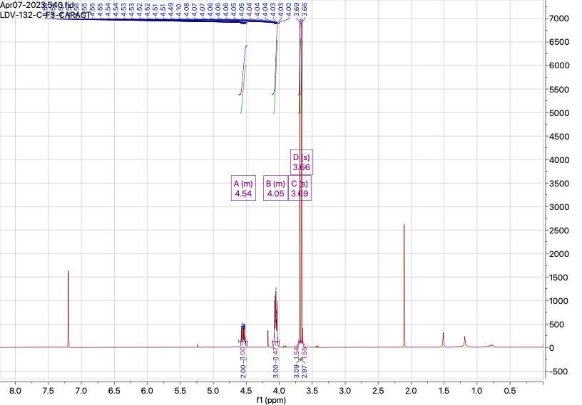
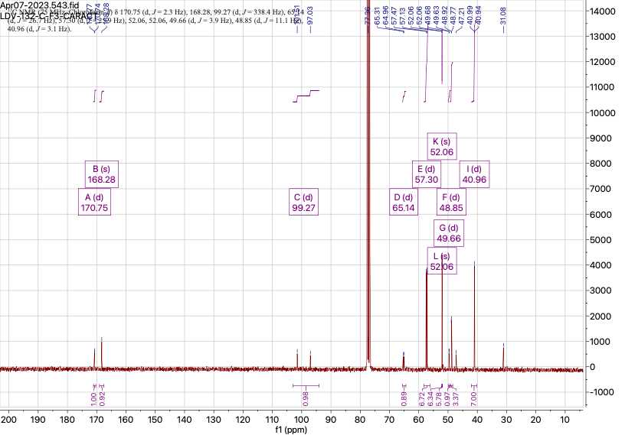
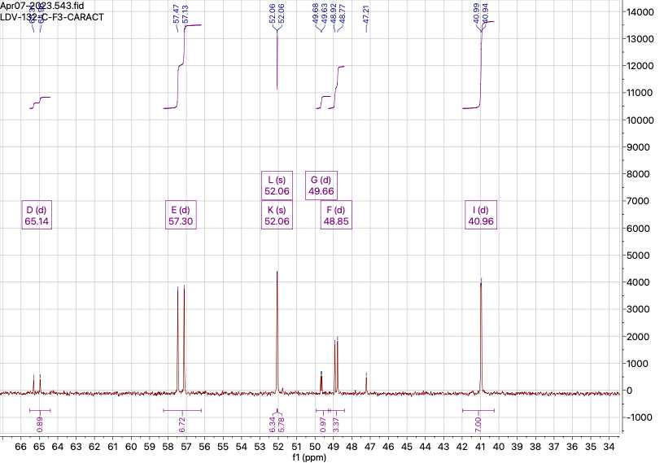
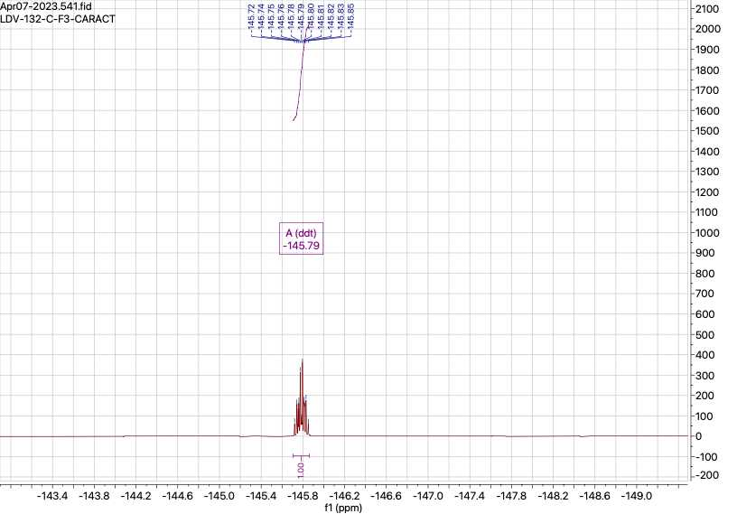

Dimethyl 2-acetylcubane-1,4-dicarboxylate
Isolated as a side product (8% yield) during the fluorination experiments with Selecfluor in MeCN.
¹H NMR (400 MHz, CDCl₃) δ 4.49 – 4.47 (m, 2H), 4.23 – 4.20 (m, 3H), 3.72 (s, 6H), 2.16 (s, 3H); ¹³C NMR (100 MHz, CDCl₃) δ 202.9, 169.0 (2C), 62.4, 53.0 (2C), 52.1, 52.0, 49.4 (2C), 47.8, 44.9 (2C), 26.1; HRMS (API) m/z: [M]⁺ Calcd for C₁₄H₁₄O₅ 262.08412; Found 262.08349
¹H NMR (400 MHz, CDCl₃)
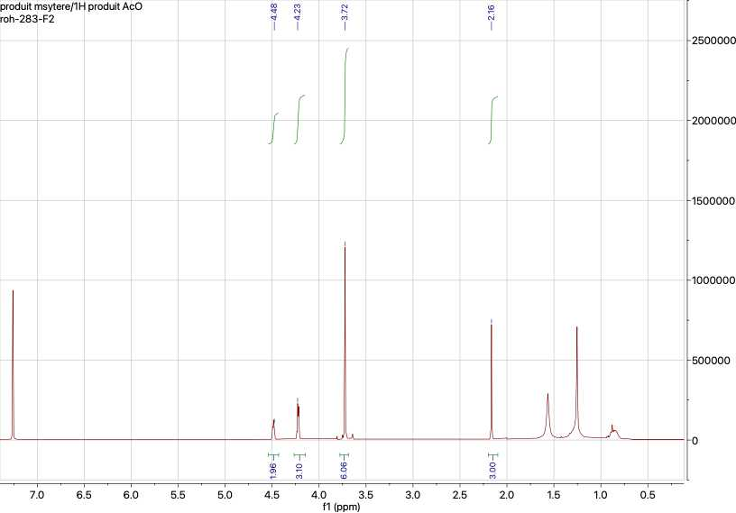
¹³C NMR DEPT (101 MHz, CDCl₃)
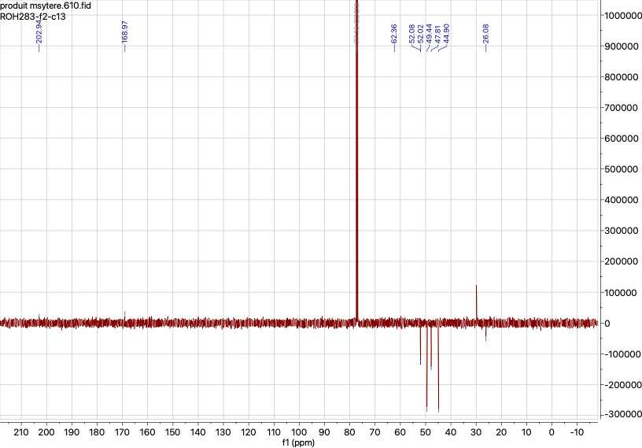
HMBC (400 MHz, CDCl₃)
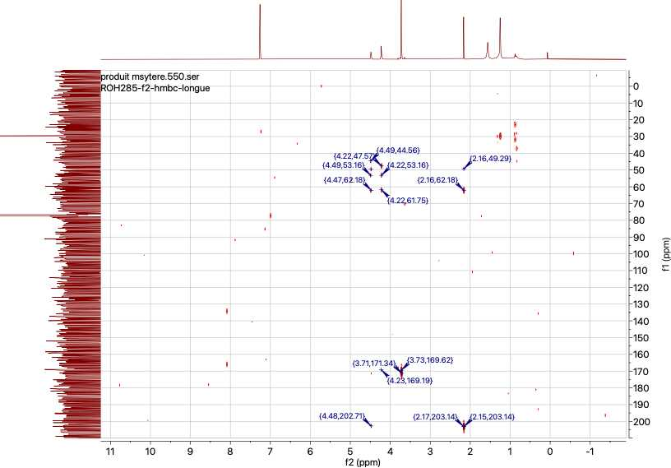
HMBC (400 MHz, CDCl₃)
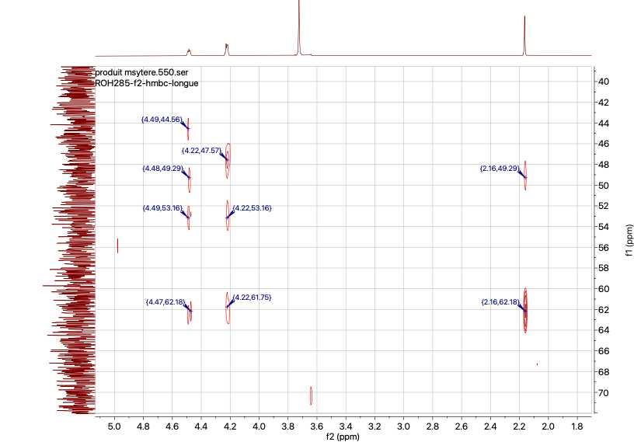
Synthesis of dimethyl 2-chlorocubane-1,4-dicarboxylate
To a 4 mL disposable glass vial, equipped with a magnetic stir bar, was added dimethyl 1,4-cubanedicarboxylate (40 mg, 0.182 mmol, 1 equiv.) and 1,3-dichloro-5,5-dimethylhydantoin (DCDMH) (25 mg, 0.127 mmol, 0.7 equiv.). The vial was degassed with an argon flow and degassed acetonitrile (4 mL) was added. The solution was stirred and irradiated using the PhotoRedOx Box™ device from EvoluChem equipped with a EvoluChem LED 365PF during 4 hours at a temperature between 25 and 40°C. Then, the reaction mixture was concentrated in vacuo. Purification by reverse phase chromatography (eluted with water/acetonitrile from 90/10 to 30/70) on a PF-15C18HP cartridge from Interchim afforded the desired product as a beige powder in 59% yield (27.5 mg).
mp 121°C; ¹H NMR (300 MHz, CDCl₃) δ 4.45 – 4.33 (m, 2H), 4.32 – 4.16 (m, 3H), 3.76 (s, 3H), 3.72 (s, 3H); ¹³C NMR (75 MHz, CDCl₃) δ 170.5, 168.5, 69.6, 62.9, 56.3 (2C), 52.9, 52.1, 52.0, 48.1, 44.1 (2C); IR (AT, cm⁻¹): ν = 3006, 1715, 1437, 1327, 1218, 1106, 1091, 794; HRMS (API) m/z: [M+H]⁺ Calcd for C₁₂H₁₂O₄³⁵Cl 255.0424; Found 255.0422; m/z: [M+H]⁺ Calcd for C₁₂H₁₂O₄³⁷Cl 257.0395; Found 257.0401
¹H NMR (400 MHz, CDCl₃)
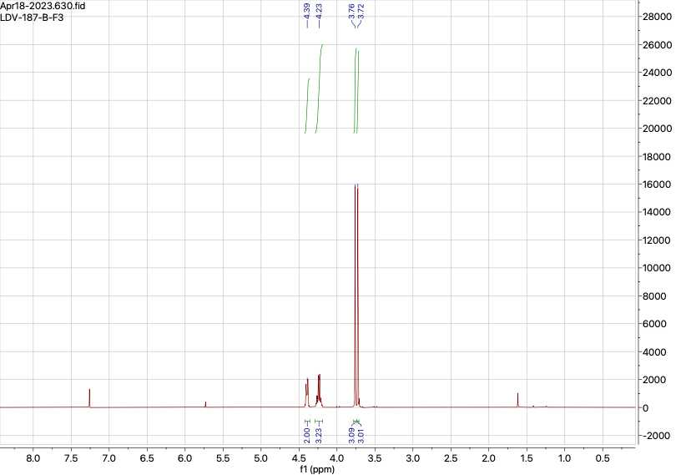

¹³C NMR (101 MHz, CDCl₃)
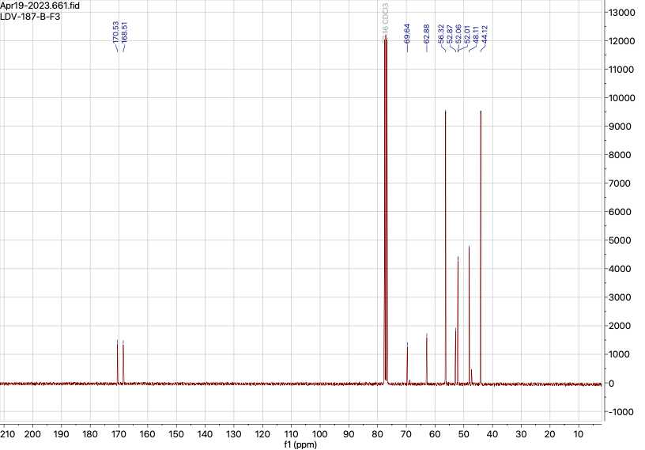
Chlorination in Flow
Dimethyl 1,4-cubanedicarboxylate (120 mg, 0.545 mmol) and DCDMH (74.8 mg, 0,380 mmol, 0.7 equiv) were placed in a vial under argon atmosphere. Dry acetonitrile (6 mL, bottle) was added. The reaction mixture was stirred and passed through the photoflow reactor (310 nm - 28°C - residence time 30 min)
Then, the reaction mixture was diluted in CH₂Cl₂ and concentrated (4 mL collection: LDV-456-coeur + beginning and end of reaction: LDV-456-ext).
Purification of LDV-456-coeur was performed by reverse phase chromatography eluted with water/CH₃CN at 35% CH₃CN (LDV-456-B-F1, 26 mg starting material) and at 40% CH₃CN (LDV-456-B-F2, 38 mg compound 3).
Yield on 4 mL collection = 41%
Yield Based on Remaining Starting Material on 4 mL collection = 61%

