This is a Word template to be used for writing manuscripts for the Beilstein Journal of Nanotechnology.
All section headers required by the Beilstein Journal of Nanotechnology and optional headers are listed. Authors are free to add subheaders (Heading 2 or Heading 3). Detailed information about the required content of each section can be found in the “Instructions for Authors”.
Please delete these paragraphs written in italic before finishing the manuscript.

Title
1st Author*¹, 2nd author^{‡2}, 3rd author^{‡2}, 4th author … and n-th author^{1,2}

Address: ¹Department, organization, address and ²Department, organization, address (if different from first address)

Email: Full name - email address of corresponding author
* Corresponding author
‡ Equal contributors

Abstract
Abstract text

Keywords
keyword; keyword; keyword; keyword; keyword

Introduction
Introduction text with an example [1] of how to cite an item in the reference list [2].

Results and Discussion (may be separate)

Heading 2

Heading 3
Results and discussion text

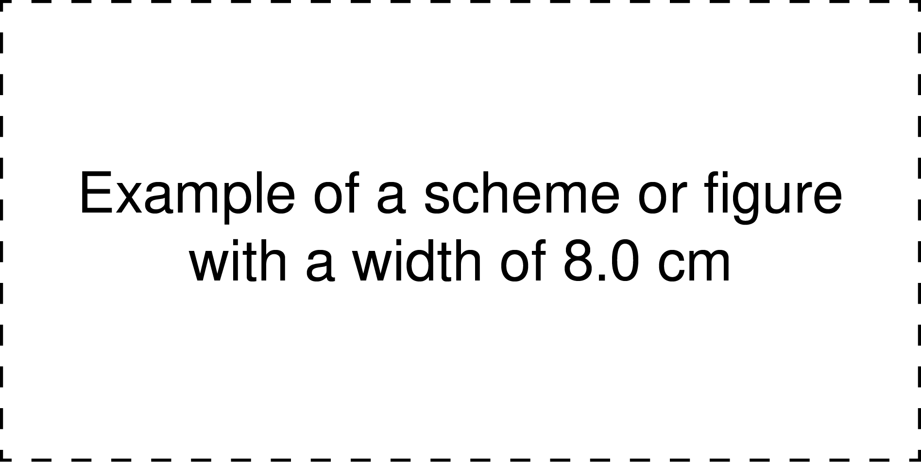
Figure 1: Description including labels such as a) and b) to reference distinct parts of the figure.

Figure 2: Description including labels such as a) and b) to reference distinct parts of the figure.

Table 1: Table titleª.
Example of a table with a width of 8.0 cm^{b}
ªTable footnote1; ^{b}Table footnote2

Table 2: Table titleª.
Example of a table with a width of 16.0 cm^{b}
ªTable footnote1; ^{b}Table footnote2

Example of an equation (maximum width of 8.0 cm)
(1)
and an example of an equation that required splitting (maximum width of 8.0 cm)
(2)

Conclusion
Conclusion text

Experimental (optional)
Experimental text

Supporting Information (if any)
Supporting information text
Supporting Information File 1:
File Name: Text
File Format: Text
Title: Text

Supporting Information File 2:
File Name: Text
File Format: Text
Title: Text

Acknowledgements (optional)
Acknowledgement text

Funding (optional)
Funding text

References
1. Author1, X. Y.; Author2, X. Y.; Author3, X. Y. Journal Title, Year, Volume, Page Begin–Page End.
2. Author1, X. Y.; Author2, X. Y.; Author3, X. Y. Journal Title, Year, in press.
etc.

